**QUESTION BANK MANAGEMENT SYSTEM  
SCRUM MEETING – TEAM ‘C’**

**SPRINT 2**

* Discussion on additional features of QBMS
* Worked on GUI design
* Worked on hibernate classes
* ER Diagrams
* Created the Database models
* Worked on jsp pages
  + Login
  + Questions
  + Answers
* Worked on features
  + User Registration
  + Login

**Additional features**

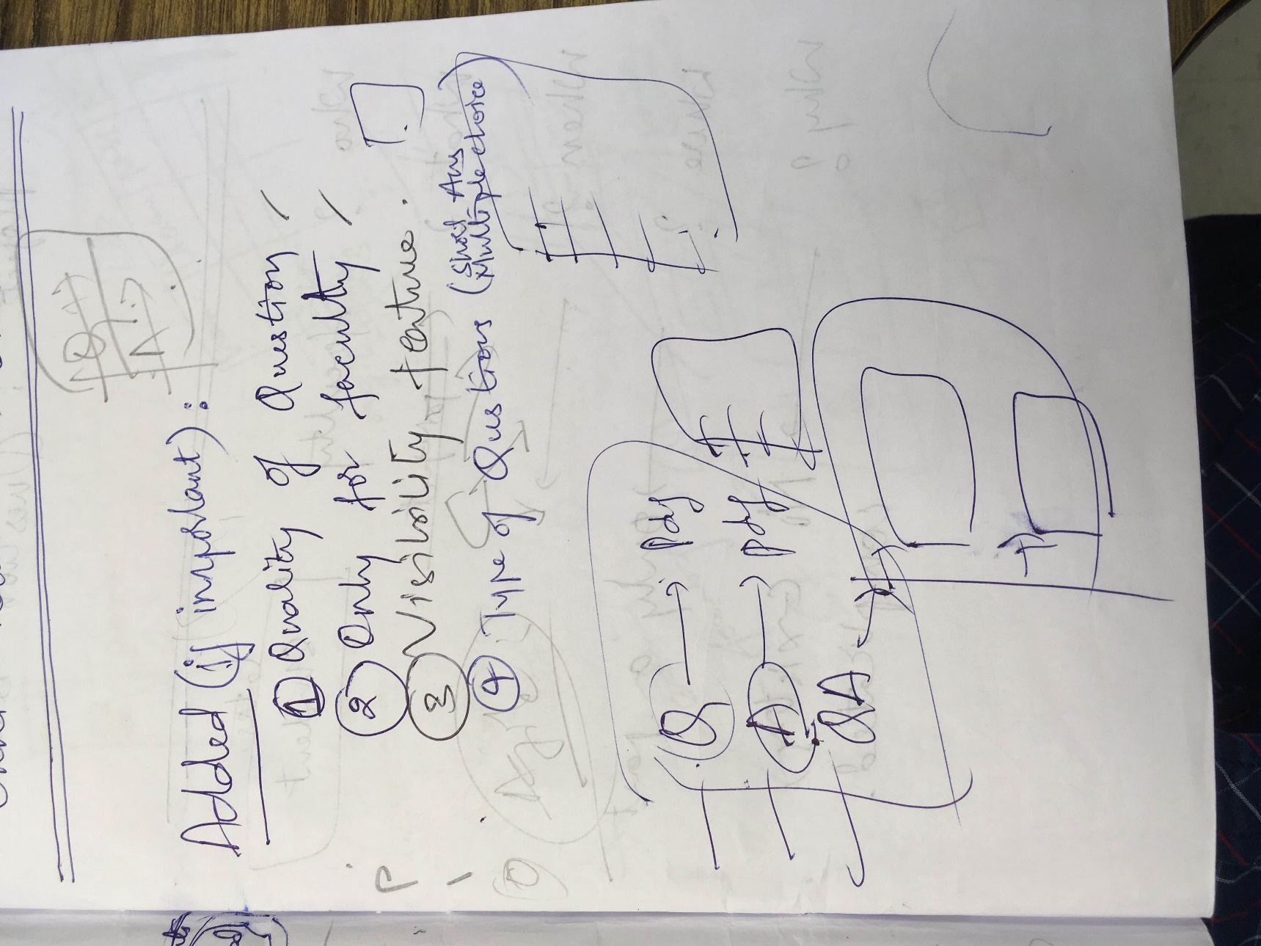

**Features of QUESTION Bank Management System**

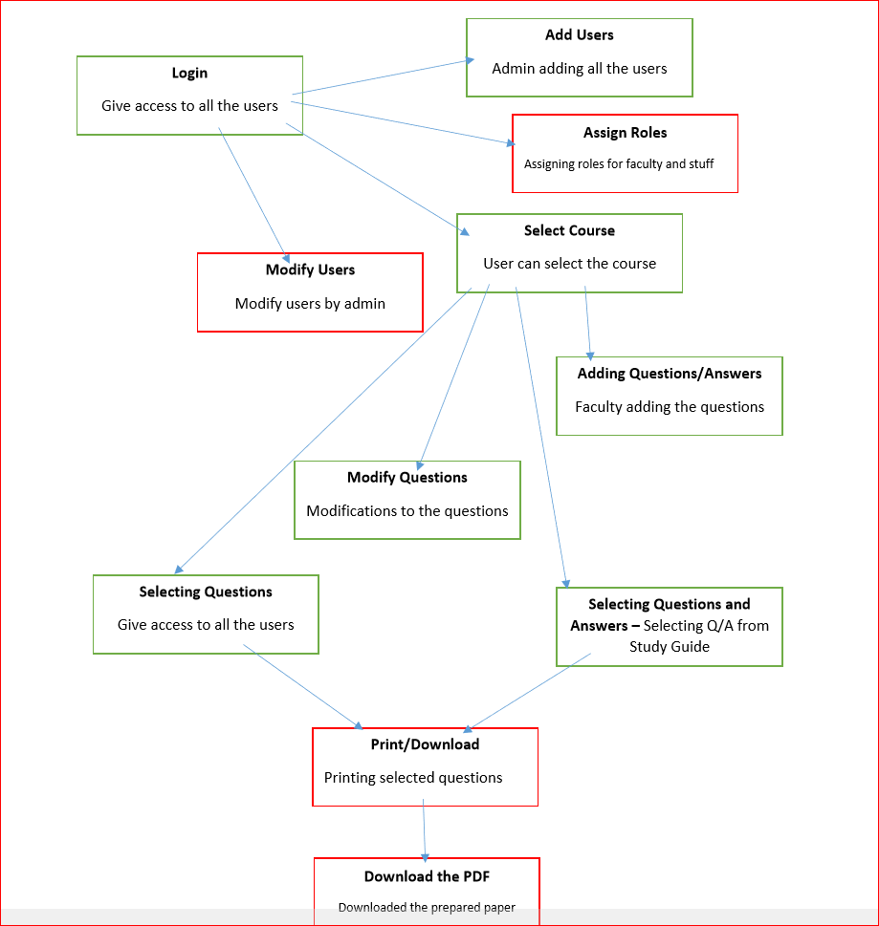

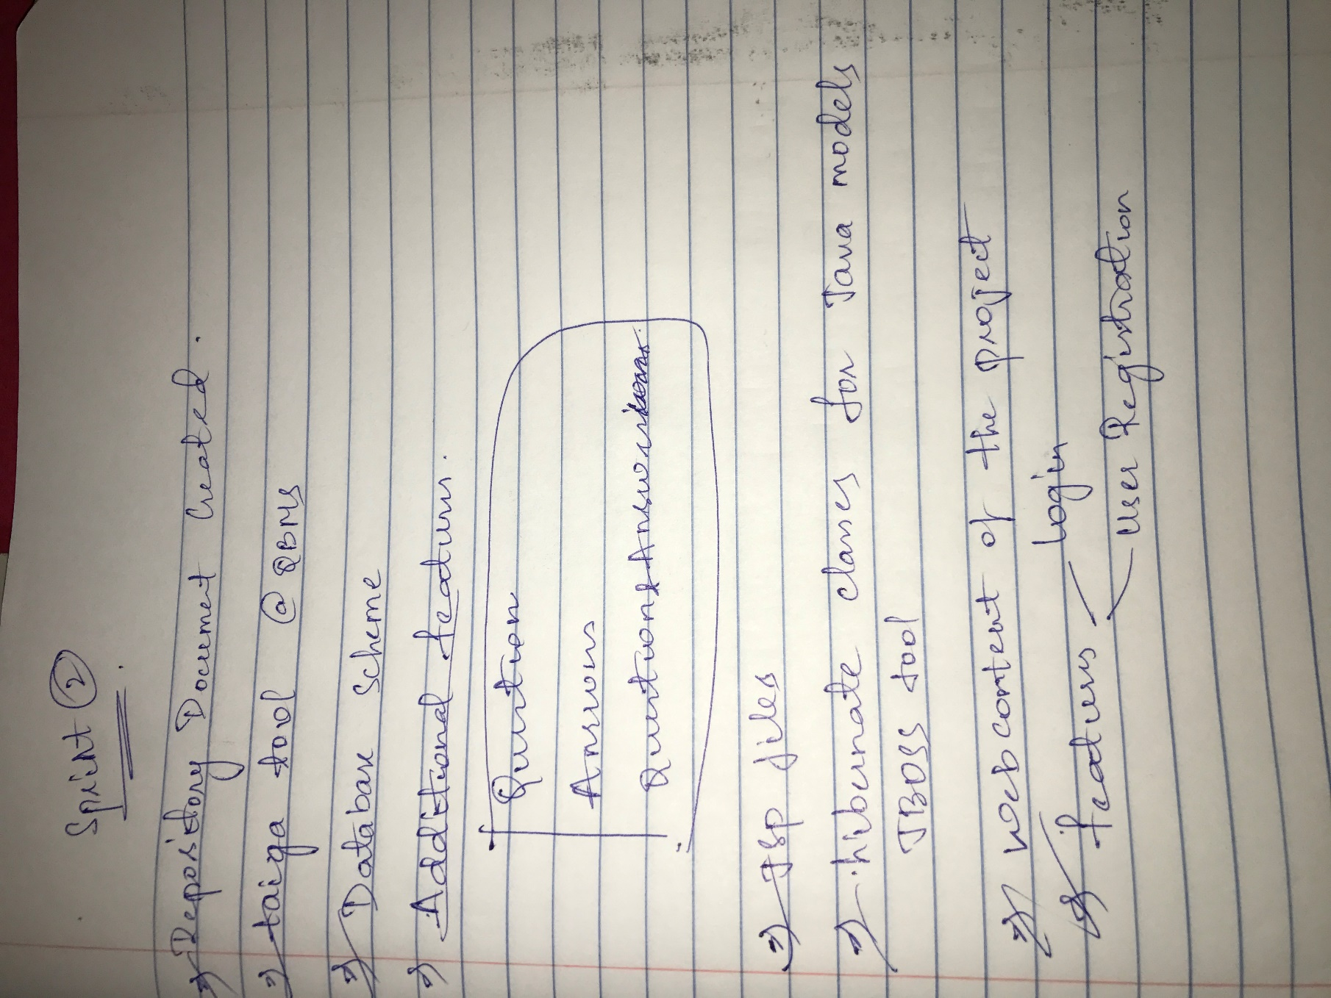

**DATABASE MODELS**



**ER DIAGRAM**

